Chara Kolokytha

Henri [Emile Benoît] Matisse (1869-1954)

Henri Matisse is a key figure, together with Picasso, in French modernism and is considered to be the most influential colourist of twentieth century art. A French painter, sculptor, and printmaker, Matisse studied painting in Paris at the École des Beaux Arts under Gustave Moreau, the École des Arts Décoratifs and the Académie Julian under W. A. Bouguereau. Works by Matisse can be found in most museums of modern art around the world in addition to the Museum Matisse in Nice and in his birthplace, Le Cateau Cambrésis, in which his art is primarily on display.

Matisse’s early paintings demonstrate a dark, sombre and dull palette and a naturalist approach to the selected themes (La liseuse, 1894), which gave progressively way to the more vivid pure colours (Still Life with Oranges, 1899; Académie bleue, 1899-1900) and impressionist execution of his works (Study of a Nude, 1899). In 1903, Matisse used intense pure colours which marked a break with naturalist and impressionist traditions (Portrait d’André Derain, 1905); thereby he inaugurated a new style that contemporary critics named Fauvism (Le Bonheur de vivre, 1905-6).

The influence of Paul Cézanne is evident in the artist’s early work and, in particular, through his conception of space, light and form. In addition to Matisse’s experimentation with Cubism, the artist studied with great interest African art (Nu debut, 1907) at the end of the first decade of the century. His interior spaces (Harmony in Red, 1908) and painted odalisques (Reclining Odalisque, 1926) owe much to his admiration for Oriental art and textiles exerting considerable influence over decorative artists. Matisse’s art also has Symbolist projections (La Danse, 1910) implying the influence of his tutor, Gustave Moreau.

From the early 1920s Matisse enjoyed worldwide reputation, being famous for his masterly coloured compositions and the joyful atmosphere of his works which became the hallmark of his overall artistic production. In the mid-1930s, the artist attempted to simplify his technique; subsequently, he introduced the so-called ‘paper cut-outs’ (papiers découpés), which he used in order to replace the drawing on the coloured surfaces of his works resulting in a collage-like composition.

In collaboration with the Parisian art critic and editor, Tériade, he perfected this technique facilitating the reproduction of these works in several luxurious livres d’artistes (artists’ books) published after the end of the Second World War. The most representative illustrated book of Matisse’s mature style is Jazz (1947), edited by Tériade, which reproduces about one hundred colour prints.

Works

La liseuse (Woman reader), oil on panel, 1895, MNAM - Centre Pompidou, Paris.

Académie bleue (Nude study in blue), oil on canvas, 1899-1900, Tate Gallery, London.

Still Life with Oranges, oil on canvas, 1899, Washington University Gallery of Art, St. Louis.

Study of a Nude, oil on canvas, 1899, Bridgestone Museum of Art, Tokyo.

Portrait d’André Derain (Portrait of André Derain), oil on canvas, 1905, Tate Gallery, London.

Le Bonheur de vivre (The Joy of life), oil on canvas, 1905-6, Barnes Foundation, Merion.

Nu debut (Female nude), oil on canvas, 1907, Tate Gallery, London.

Harmony in Red, oil on canvas, 1908, Hermitage, St. Petersburg.

La Danse (The Dance), oil on canvas, 1910, Hermitage, St. Petersburg.

Reclining Odalisque, oil on canvas, 1926, Metropolitan Museum of Art, New York.

Illustrations
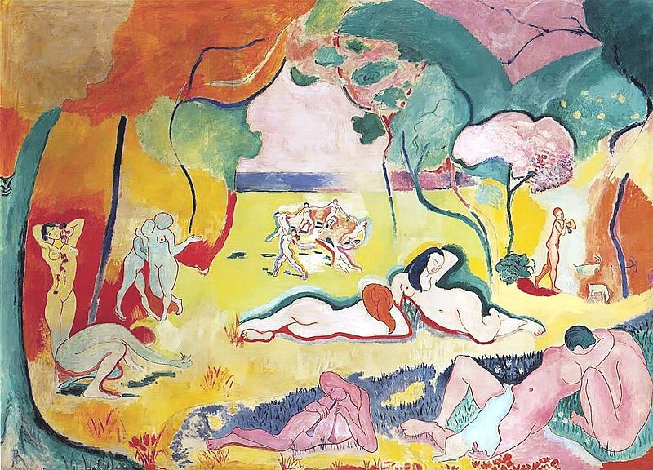

Le Bonheur de vivre (The Joy of life), oil on canvas, 1905-6, Barnes Foundation, Merion.
http://en.wikipedia.org/wiki/File:Bonheur_Matisse.jpg

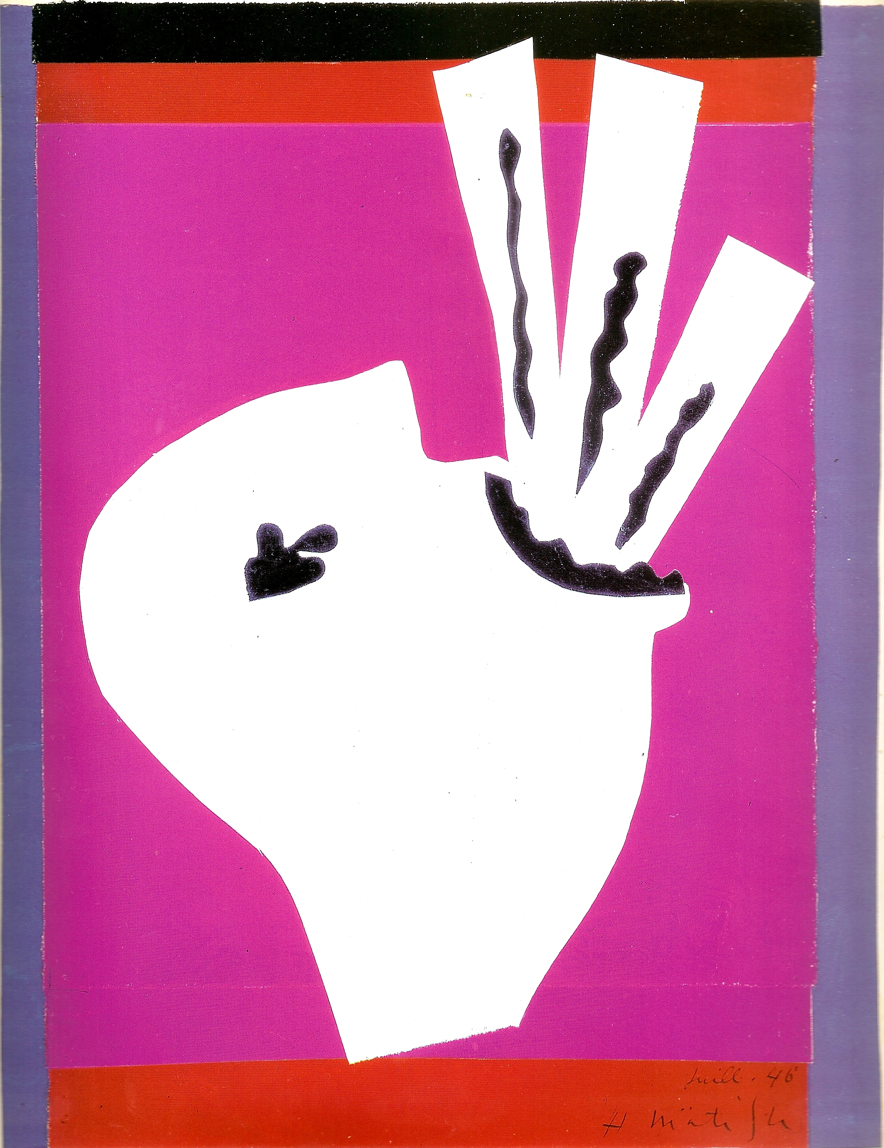

Henri Matisse, L’Avaleur de sabres, 1943-44, print from Jazz, Paris, Tériade, 1947.

Useful Links

Official site of the Museum Matisse, Nice:
http://www.musee-matisse-nice.org/
Official site of the Museum Matisse, Le Cateau Cambrésis:
http://museematisse.cg59.fr/fr/Accueil/tabid/40/Default.aspx

Films

Henri Matisse (1946) documentary, directed by Francois Campaux (French)
Henri Matisse ou le talent du Bonheur, (1960) documentary, directed by Marcel Ophuls (French)
Henri Matisse dans le midi (1996) Omega films, directed by Charles de Lartique (French)

References and further reading

Barr, A. H. (1951) Matisse: his Art and his Public, New York, The Museum of Modern Art.

Flam, J. (1996) Matisse on Art, Berkeley, University of California Press.

Weiss Bock, C. C. (1996) Henri Matisse: A Guide to Research, London and New York, Routledge.

Szymusiak, D., Di Crescenzo C. (1997) Matisse et Tériade, exh. cat. Musée Matisse, Le Cateau Cambrésis, Anthèse.

Henri Matisse: notes d’un peintre (2012) exh. cat. Paris, Centre Pompidou.

Rabinow, R., Aagesen, D. (2012) Matisse: In search of true painting, exh.cat. New York, Metropolitan Museum of Art.

Cronan, T. (2013) Against Affective Formalism: Matisse, Bergson, Modernism, University of Minnesota Press.

McBreen, E. (2013) Matisse’s sculpture: the pinup and the primitive, New Haven, Yale University Press.

